Homework 2:
- Consider the following binary tree
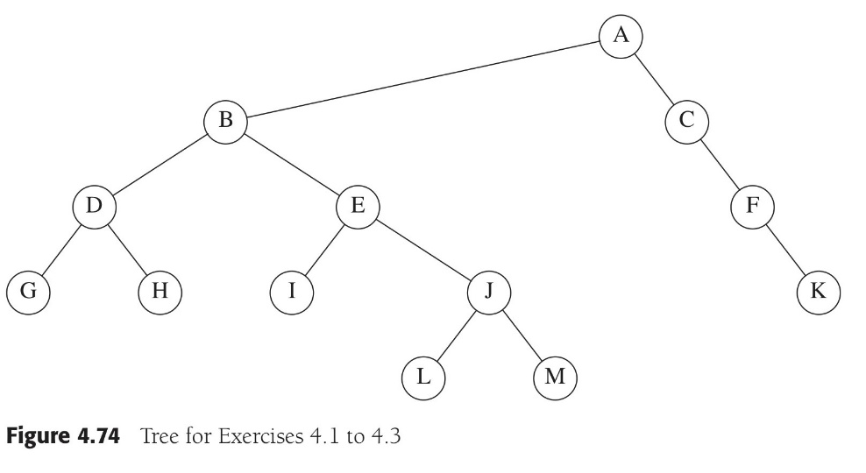
- Which node is the root?
- Which nodes are leaves?
- Which node is the parent of node B?
- Which nodes are children of node B?
- Which nodes are the siblings of node B?
- What is the tree height?
- Give the results of pre-order, in-order, post-order, level-order traversals of the tree.

- Each node in a binary tree is represented by a letter. The pre-order traversal of the tree is ABDECFGH, and the in-order traversal is EDBACGFH. Draw the tree.

